EXP - 02.
DATE: 10/07/26
DDL Commands with Constraints – PRIMARY, FOREIGN KEY, UNIQUE, CHECK
AIM:
To add constraints like PRIMARY KEY, FOREIGN KEY, UNIQUE KEY, and CHECK using DDL commands in the Saveetha Hospital database.
Description:
- PRIMARY KEY: Ensures each record in a table is uniquely identified.
- FOREIGN KEY: Links two tables together, referencing the primary key of another table.
- UNIQUE: Ensures all values in a column are different.
- CHECK: Restricts values in a column to a defined condition.
Questions (Saveetha Hospital Context)
- Alter the table PATIENT with following structure
  - Column: PatientID → PRIMARY KEY

sql
ALTER TABLE Patient ADD PRIMARY KEY(PatientID);
- Alter the table FACULTY with following structure
  - Column: FacNo → PRIMARY KEY
  - Column: Gender → CHECK (‘M’ or ‘F’)
sql
ALTER TABLE Faculty ADD PRIMARY KEY(FacNo);
ALTER TABLE Faculty ADD CONSTRAINT chk_gender CHECK (Gender IN ('M','F'));
- Alter the table DEPARTMENT with following structure
  - Column: DeptNo → PRIMARY KEY
sql
ALTER TABLE Department ADD PRIMARY KEY(DeptNo);

- Alter the table COURSE with following structure
  - Column: CourseNo → PRIMARY KEY
  - Column: SemNo → CHECK (SemNo BETWEEN 1 AND 6)
sql
ALTER TABLE Course ADD PRIMARY KEY(CourseNo);
ALTER TABLE Course ADD CONSTRAINT chk_sem CHECK (SemNo BETWEEN 1 AND 6);
- Alter the table PATIENT with following structure
  - Column: PatientName → UNIQUE KEY
sql
ALTER TABLE Patient ADD CONSTRAINT unique_patient UNIQUE(PatientName);

6.) After the STUDENT2 & STUDENT3 tables are successfully created, test if you can add a constraint FOREIGN KEY to the RegNo of this table.
OUTPUTS:
1.
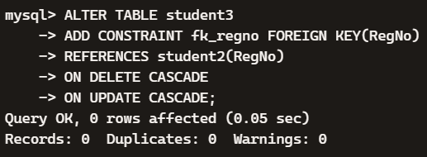

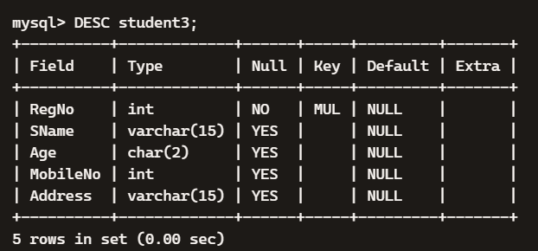
2.
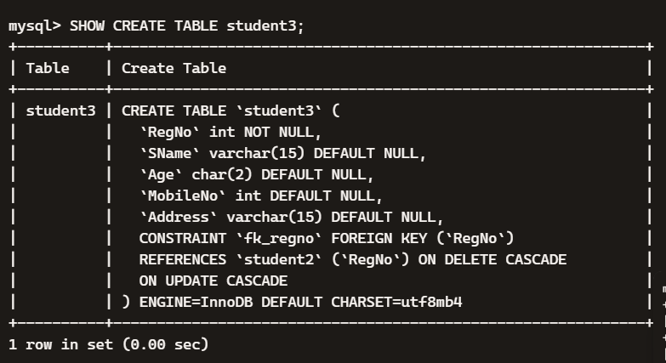
3.
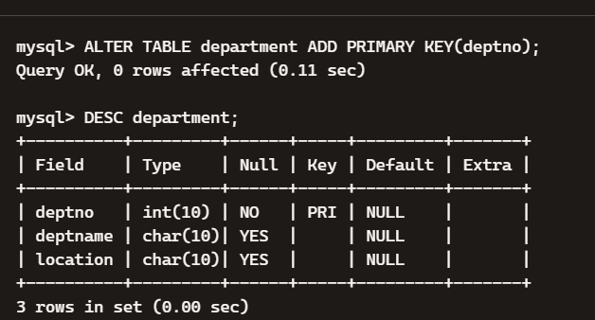
4.
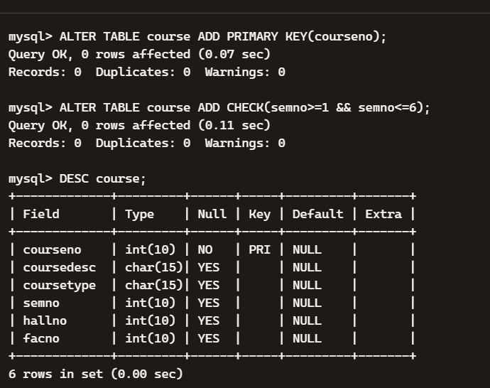
5.
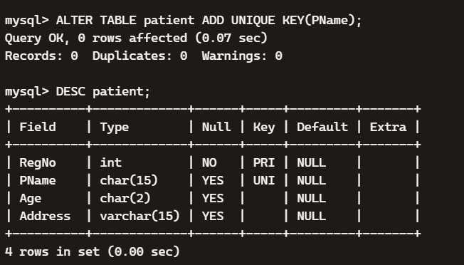
6.
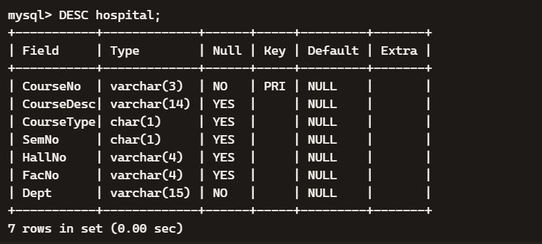

RESULT:
This is the concise confirmation line MySQL shows after successfully executing the ALTER TABLE command.

